Rakshith Churchagundi Amarnath

A20424771

Assignment 7

1)

Magic Number = 230700



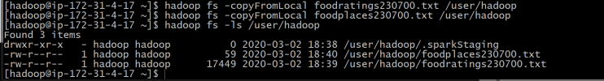

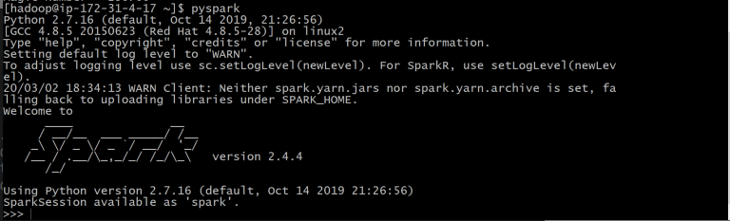

>>> ex1RDD=sc.textFile("./foodratings230700.txt")

>>> print ex1RDD.take(5)



2)

>>> ex2RDD = ex1RDD.map(lambda line: line.split(","))

>>> print ex2RDD.take(5)



3)

>>> ex3RDD = ex2RDD.map(lambda line : [line[0], line[1], int(line[2]), line[3], line[4], line[5]])

>>> print ex3RDD.take(5)



4)

>>> ex4RDD=ex3RDD.filter(lambda line: line[2]<25)

>>> print ex4RDD.take(5)



5) >>> ex5RDD=ex4RDD.map(lambda x:(x[0], x))

>>> print ex5RDD.take(5)



6)

>>> ex6RDD=ex5RDD.sortByKey()

>>> print ex5RDD.take(5)

